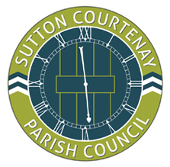

Sutton Courtenay Parish Council

To: All Members of the Council

You are hereby summoned to attend an Extraordinary Meeting of the Parish Council to be held on Tuesday 20th April 2021 at 7.15pm virtually, via Zoom Meetings.

Councillor Michael Jenkins
(Chair)

Date: 15th April 2021

- Apologies for Absence
To receive apologies for absence

- Declarations of Interest
- To receive declarations of interest from Councillors on items on the agenda under consideration at this meeting
- To receive written requests for dispensations for discloseable pecuniary interests.
- To grant any requests for dispensation as appropriate

- Proposed River crossing and Clifton Hampden bypass
- To review the email from Oxfordshire County Council.
- To resolve to write to Robert Jenrick, Secretary of State for Housing, Communities and Local Government to request an extension for the HIF funding.

